Mobile Application Lab Exercise 4-A

Creating Mobile App with Intent technique for communicating between the components of an Application and also from one application to another application.
Follow the steps below;

- Open Android Studio and create a new Mobile App called MyIntentApp, and make sure you are selecting JAVA programming language.
- Wait until the Mobile App completed its settings
- Open the file activity_main.xml in design mode, and create TextView field and TWO buttons (see below)

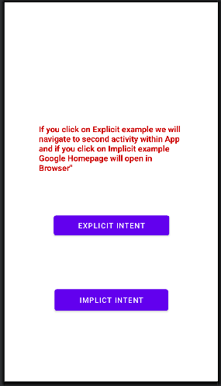

- Add the following text “If you click on EXPLICIT INTENT button we will navigate to second activity with the mobile application, and if you click on IMPLICIT INTENT button Google home page will in browser” in the TextView.

- Create a new Activity (i.e new java program) in the same folder as MainActivity.java and it is called as SecondActivity.java

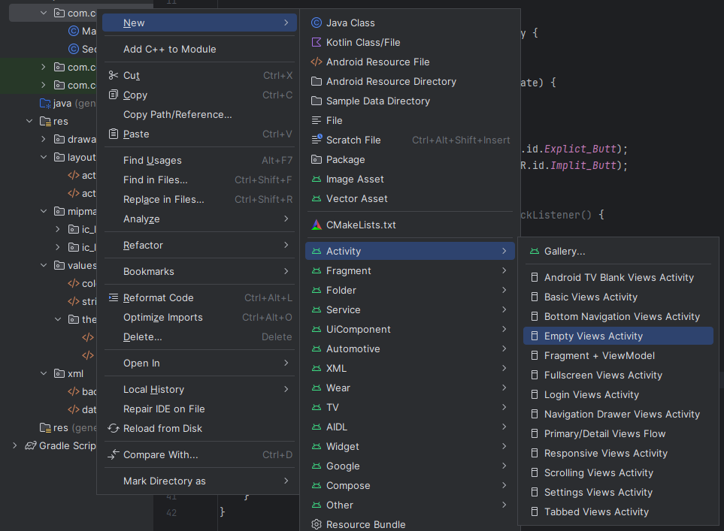

- Add the following java code in MainActivity.java file

Button exintent = (Button) findViewById(R.id.Explicit_Butt);
Button impintent = (Button) findViewById(R.id.Implicit_Butt);

- Add the following java code to the exintent button.

exintent.setOnClickListener(new View.OnClickListener() {
@Override
public void onClick(View view) {
Intent intent = new Intent(getBaseContext(), SecondActivity.class);
startActivity(intent);
}
});

- Add the following java code to the impintent button.

impintent.setOnClickListener(new View.OnClickListener() {
@Override
public void onClick(View view) {
Intent intent = new Intent(Intent.ACTION_VIEW);
intent.setData(Uri.parse("https://www.google.com"));
startActivity(intent);
}
});

- Open the file activity_second.xml in design mode and change the TextView text to “Second Activity”, and add a button with label “BACK TO MAIN” as the following (see below)
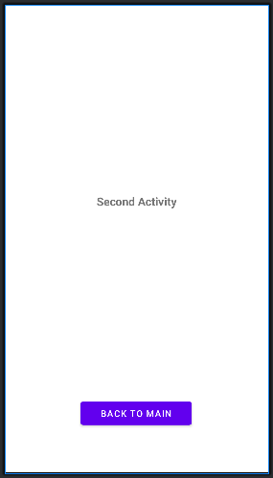
- Add the following java codes to SecondActivity.java file

Toast.makeText(getApplicationContext(), "We are moved to second Activity", Toast.LENGTH_LONG).show();
Button Backbutt = (Button) findViewById(R.id.buttback);
Backbutt.setOnClickListener(new View.OnClickListener() {
@Override
public void onClick(View view) {
Intent mainActivityIntent = new Intent(
getApplicationContext(), MainActivity.class);
startActivity(mainActivityIntent);
}
});

- Change the AndroidManifest.xml, by adding the following

<activity
android:name=".MainActivity"
android:exported="true">
<intent-filter>
<action android:name="android.intent.action.MAIN" />
<category android:name="android.intent.category.LAUNCHER" />
</intent-filter>
</activity>
<activity
android:name=".SecondActivity"
android:label="@string/second_app"
android:exported="false" />

- Now compile and run your application for testing.

Mobile Application Lab Exercise 4-B

- To add status bar to show your Application name, you need to change the Colors.xml file, and the themes.xml file as follow.

colors.xml
<?xml version="1.0" encoding="utf-8"?>
<resources>
<color name="purple_200">#FFBB86FC</color>
<color name="purple_500">#FF6200EE</color>
<color name="purple_700">#FF3700B3</color>
<color name="teal_200">#FF03DAC5</color>
<color name="teal_700">#FF018786</color>
<color name="black">#FF000000</color>
<color name="white">#FFFFFFFF</color>
</resources>

themes.xml
<resources xmlns:tools="http://schemas.android.com/tools">
<!-- Base application theme. -->
<style name="Base.Theme.MyIntent" parent="Theme.MaterialComponents.DayNight.DarkActionBar">
<!-- Customize your dark theme here. -->
<!-- <item name="colorPrimary">@color/my_dark_primary</item> -->
<item name="colorPrimary">@color/purple_500</item>
<item name="colorPrimaryVariant">@color/purple_700</item>
<item name="colorOnPrimary">@color/white</item>
<!-- Secondary brand color. -->
<item name="colorSecondary">@color/teal_200</item>
<item name="colorSecondaryVariant">@color/teal_700</item>
<item name="colorOnSecondary">@color/black</item>
<!-- Status bar color. -->
<item name="android:statusBarColor">?attr/colorPrimaryVariant</item>
</style>
</resources>

- Now compile and run your application for testing

- If your application works fine, then change the ConstraintLayout in both files activity_main.xml, and activity_second.xml to the RelativeLayer, or LinearLayer and rearrange all the components within the RelativeLayer or LinearLayer UI.

Mobile Application Lab Exercise 4-C
- Open Android Studio and create a new Mobile App called MyIntent2, and make sure you are selecting JAVA programming language.
- Wait until the Mobile App completed its settings
- To add status bar to show your Application name, you need to change the Colors.xml file, and the themes.xml file as follow.

colors.xml
<?xml version="1.0" encoding="utf-8"?>
<resources>
<color name="purple_200">#FFBB86FC</color>
<color name="purple_500">#FF6200EE</color>
<color name="purple_700">#FF3700B3</color>
<color name="teal_200">#FF03DAC5</color>
<color name="teal_700">#FF018786</color>
<color name="black">#FF000000</color>
<color name="white">#FFFFFFFF</color>
</resources>

themes.xml
<resources xmlns:tools="http://schemas.android.com/tools">
<!-- Base application theme. -->
<style name="Base.Theme.MyIntent" parent="Theme.MaterialComponents.DayNight.DarkActionBar">
<!-- Customize your dark theme here. -->
<!-- <item name="colorPrimary">@color/my_dark_primary</item> -->
<item name="colorPrimary">@color/purple_500</item>
<item name="colorPrimaryVariant">@color/purple_700</item>
<item name="colorOnPrimary">@color/white</item>
<!-- Secondary brand color. -->
<item name="colorSecondary">@color/teal_200</item>
<item name="colorSecondaryVariant">@color/teal_700</item>
<item name="colorOnSecondary">@color/black</item>
<!-- Status bar color. -->
<item name="android:statusBarColor">?attr/colorPrimaryVariant</item>
</style>
</resources>

- Change the default ConstraintLayout in activity_main.xml file, to the LinearLayer and rearrange all the components within the LinearLayer UI.
- Open the file activity_main.xml in design mode, and create EditText view with multiple lines of enters with android:id = @+id/edit_message and ONE button with android:id=@+id/buttsend (see below)
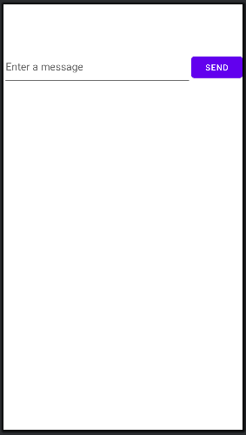
- Define a final constant as string (see below) before onCreate() method in MainActivity.java file

public final static String EXTRA_MESSAGE = "com.example.myintent2.MESSAGE";

- Add OnClickListener to Send button as shown below;
Button Sendkbutt = (Button) findViewById(R.id.buttsend);
Sendbutt.setOnClickListener(new View.OnClickListener() {
@Override
public void onClick(View view) {
Intent intent = new Intent(this, DisplayMessageActivity.class);
EditText editText = (EditText) findViewById(R.id.edit_message);
String message = editText.getText().toString();
intent.putExtra(EXTRA_MESSAGE, message);
startActivity(intent);
}
});

- Now, create a new Activity (i.e new java program) in the same folder as MainActivity.java and it is called DisplayMessageActivity.java



- Remove the TextView component from the activity_display_message.xml file

- Rewrite onCreate() method in Display MessageActivity.java file, by adding extra java codes as shown below;
@Override
public void onCreate(Bundle savedInstanceState) {
super.onCreate(savedInstanceState);
// Get the message from the intent
Intent intent = getIntent();
String message = intent.getStringExtra(MainActivity.EXTRA_MESSAGE);
// Create the text view
TextView textView = new TextView(this);
textView.setTextSize(40);
textView.setText(message);
// Set the text view as the activity layout
setContentView(textView);
}

- Now compile and run your application for testing. Your results should be something like this.

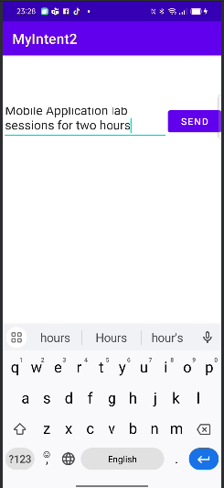 | 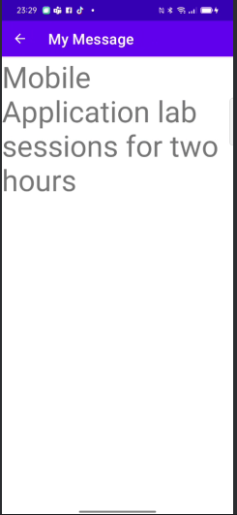

Mobile Application Lab Exercise 4-D
Now let’s to add a menu to a Mobile App by following the steps below;

- Open Android Studio and create a new Mobile App called MyMenuApp, and make sure you are selecting JAVA programming language.
- Wait until the Mobile App completed its settings
- Open the file activity_main.xml in design mode, and you will see a single TextView component with Hello World! Message.
- Add a new sub-folder called menu under res folder of your application.By By clicking the right-hand side of the mouse on res folder and then select Android Resource Directory (see below).
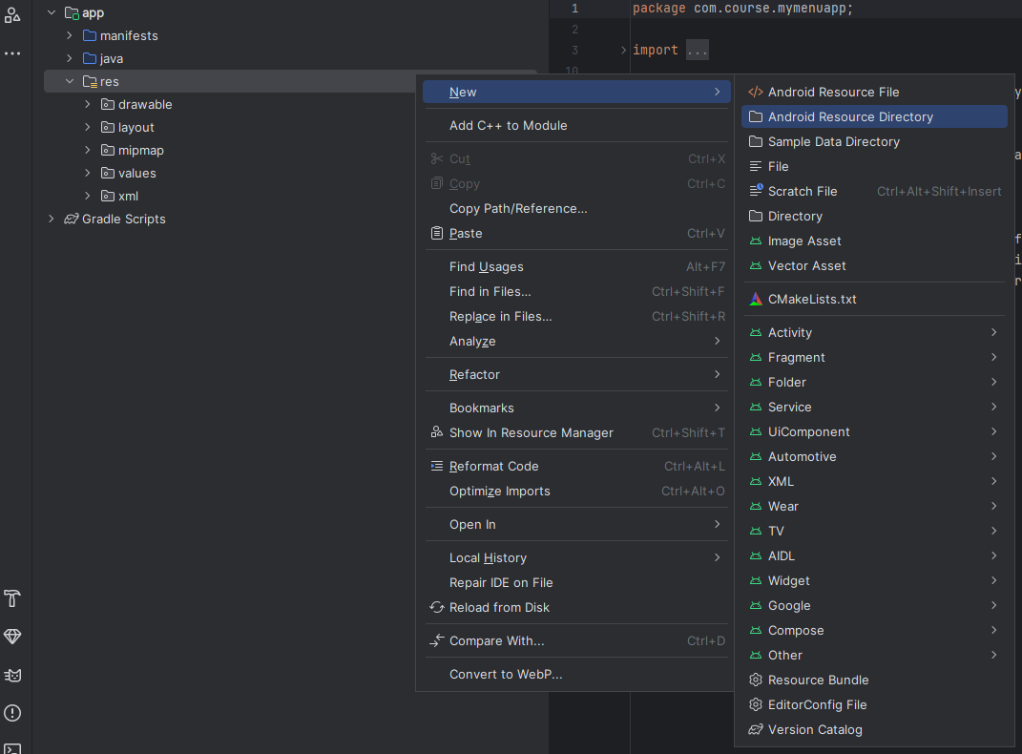
Then select the option menu from Resource type drop list (see below), and click Ok
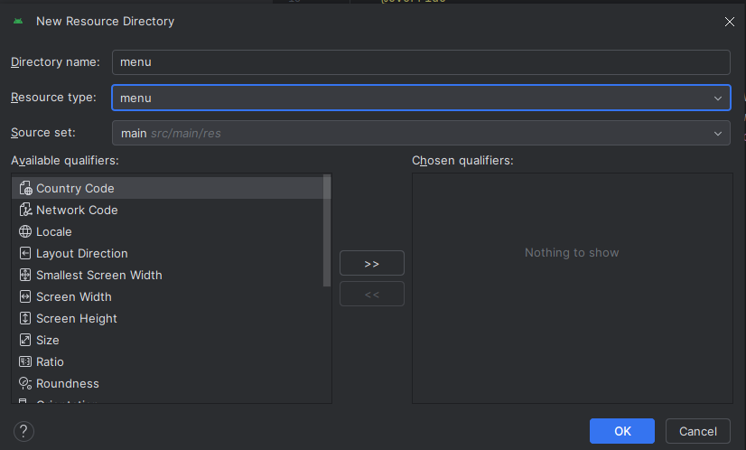
Now, click the right button of the mouse on the menu folder, then select Menu Resource File option (see below).
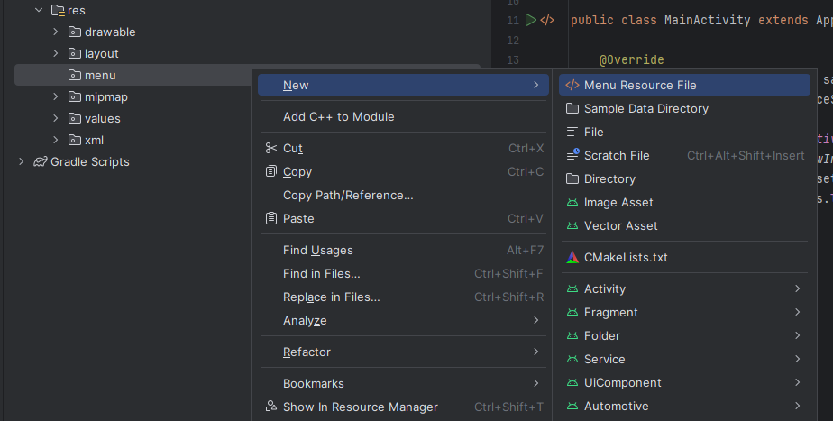
Add the file name as menu.xml and click OK (see below)
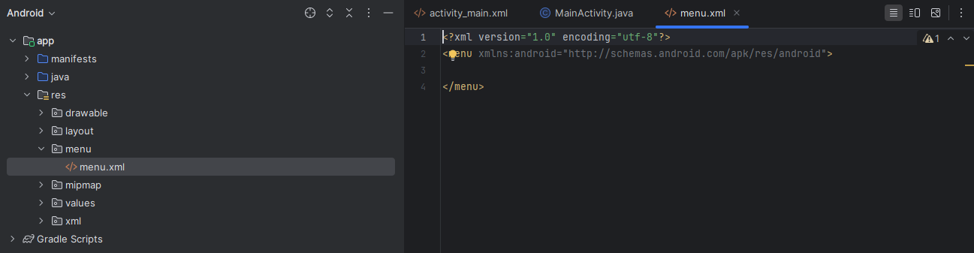
Add the following code in menu.xml file
<?xml version="1.0" encoding="utf-8"?>
<menu xmlns:android="http://schemas.android.com/apk/res/android">
<item
android:id="@+id/item1"
android:enabled="true"
android:title="New"
android:visible="true" />
<item
android:id="@+id/item2"
android:title="Open" />
<item
android:id="@+id/item3"
android:enabled="true"
android:title="Delete"
android:visible="true" />
</menu>

Now, open the MainActivity.java file and import the following packages

import android.view.Menu;
import android.view.MenuItem;

and add the following code after onCreate() method
@Override
public boolean onCreateOptionsMenu(Menu menu) {
getMenuInflater().inflate(R.menu.menu, menu);
return true;
}

Also, you need to the following codes for menu options
@Override
public boolean onOptionsItemSelected(MenuItem item) {
int itemId = item.getItemId(); // get selected menu item's id
// check selected menu item's id and replace a Fragment Accordingly
if (itemId == R.id.item1) {
Toast.makeText(MainActivity.this,"You select Option 1",Toast.LENGTH_SHORT).show();
} else if (itemId == R.id.item2) {
Toast.makeText(MainActivity.this,"You select Option 2",Toast.LENGTH_SHORT).show();
} else if (itemId == R.id.item3) {
Toast.makeText(MainActivity.this,"You select Option 3",Toast.LENGTH_SHORT).show();
}
return true;
}

Now compile and run your application for testing

